**Adding Tools**

**Step one:** Clone the test Lab environment Following step 1A orinstall from scratch on development computer Following steps from 1B

**1A)Steps for cloning**

Open virtualbox and right click the test machine and click the sheep that says clone

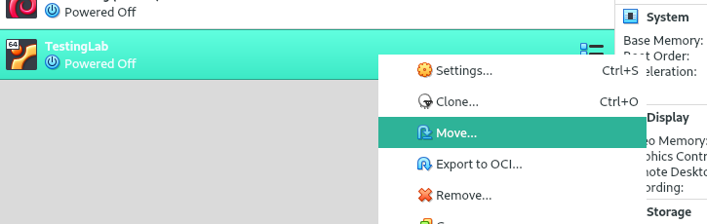

Next, name the clone machine and leave the options at default and click next

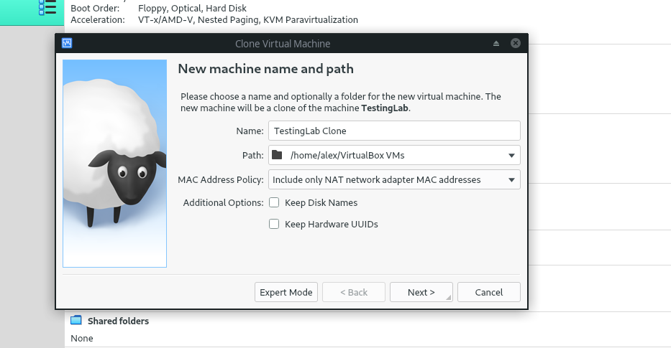

Then select full clone and click clone this may take a while

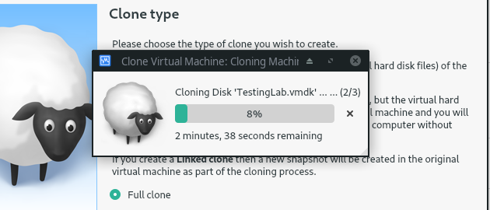

After the clone is done open the machine and follow the testing standards to make sure that the tools are working.

**1B) From scratch:**

Follow the “Installing ubuntu on virtualbox” documentation to install ubuntu, then follow the installation document of each tool that has already been added to the suite until you have a working environment.

Afterwards run through the testing documentation to check if the installations were successful

**Step two:**

Install the tool on the clone machine and test it. The previously installed tools need to be checked to make sure that the installation did not break them. In the Documentation you will find the test each tool needs to pass to verify functionality.

**Step three:**

Document how to install your tool and testing of your tool following the Documentation standards. An example of these being implemented can be found in the “Installing Openvas on ubuntu 18” and “Testing openvas” documents.

**Step four:**

Rename the Current testing machine to “Backup” and the clone machine to “Testing lab” this can be accomplished in the general settings tab

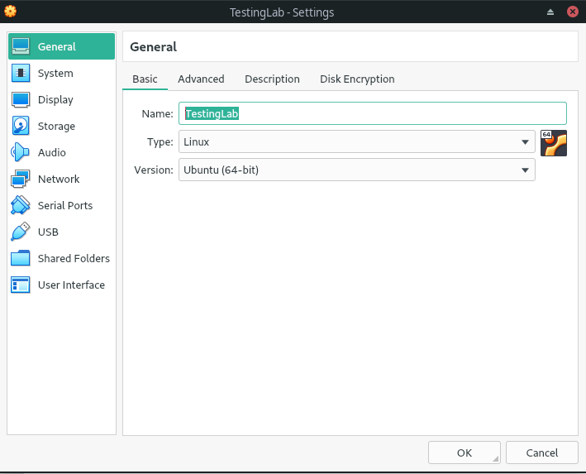

** if you installed From scratch on another machine you will need to export the machine to a .ova file and import it into the test environment

After this create a link to the virtual machine on the desktop by right clicking on the Testing lab machine and selecting the option. Students will be able to use this environment now

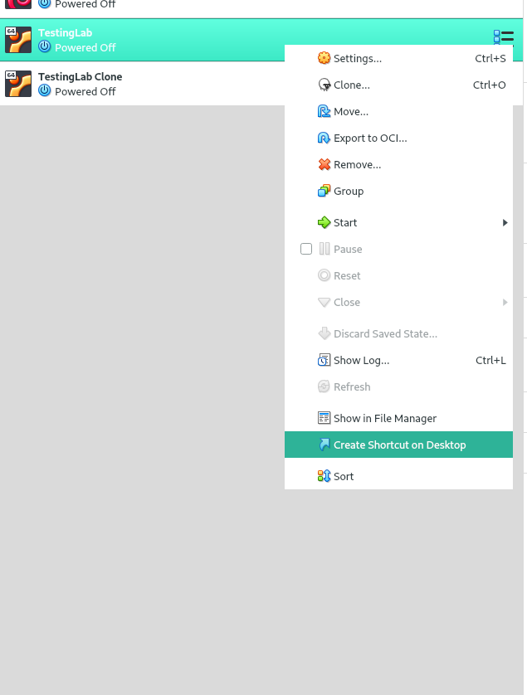

**Step five Finalization:**

After the environment has been used without issues for at least 3 weeks you can export the machine into a .ova and remove the old backups.